|  |  |  |  |
| --- | --- | --- | --- |
| 1 | | 19,095 | |
| **NUMERO DE FRONTERAS** | | **ENERGIA AGREGADA** | |
|  | | | |
| 6,802,134 | 13 | | 0 |
| INGRESO 2019 | DÍAS CERTIFICADOS 2019 | | ENERGIA RESPALDADA 2019 |
|  | | | |
| 66,019,147 | 156 | | 2,382,222 |
| INGRESO 2020 | DÍAS CERTIFICADOS 2020 | | ENERGIA RESPALDADA 2020 |
|  | | | |
| 45,646,378 | 127 | | 2,028,926 |
| INGRESO 2021 | DÍAS CERTIFICADOS 2021 | | ENERGIA RESPALDADA 2021 |

**HISTORICO REINTEGRO DDV**

|  |  |  |  |
| --- | --- | --- | --- |
|  | **2019** | **2020** | **2021** |
| **ENE** | - | 12.43 | 0.36 |
| **FEB** | - | 15.56 | 5.69 |
| **MAR** | - | 16.16 | 1.91 |
| **ABR** | - | - | - |
| **MAY** | - | 3.15 | 4.76 |
| **JUN** | - | 6.29 | 3.97 |
| **JUL** | - | 4.89 | 8.11 |
| **AGO** | - | 5.95 | 5.52 |
| **SEP** | 4.74 | - | 7.96 |
| **OCT** | 2.06 | 1.58 | 7.36 |
| **NOV** | - | - | - |
| **DIC** | - | - | - |

**Los valores de la tabla están en millones de COP**

**REINTEGRO MECANISMO DDV OCTUBRE 2021**

|  |  |  |  |  |  |
| --- | --- | --- | --- | --- | --- |
| FECHA | TIPO DIA | CANTIDADES RESPALDO | PRECIO PONDERADO USD | TRM | PNETO |
| 2021-10-04 | Lunes | 19,102 | 5.98 | 3,784.44 | 387,338 |
| 2021-10-05 | Martes | 19,103 | 5.98 | 3,784.44 | 387,358 |
| 2021-10-06 | Miércoles | 19,030 | 5.98 | 3,784.44 | 385,878 |
| 2021-10-07 | Jueves | 19,102 | 5.98 | 3,784.44 | 387,338 |
| 2021-10-08 | Viernes | 19,102 | 5.98 | 3,784.44 | 387,338 |
| 2021-10-09 | Sábado | 19,102 | 5.98 | 3,784.44 | 387,338 |
| 2021-10-10 | Domingo - Festivo | 19,102 | 5.98 | 3,784.44 | 387,338 |
| 2021-10-11 | Lunes | 19,102 | 5.98 | 3,784.44 | 387,338 |
| 2021-10-18 | Domingo - Festivo | 19,030 | 5.98 | 3,784.44 | 385,878 |
| 2021-10-19 | Martes | 19,102 | 5.98 | 3,784.44 | 387,338 |
| 2021-10-20 | Miércoles | 19,102 | 5.98 | 3,784.44 | 387,338 |
| 2021-10-21 | Jueves | 19,102 | 5.98 | 3,784.44 | 387,338 |
| 2021-10-22 | Viernes | 19,031 | 5.98 | 3,784.44 | 385,898 |
| 2021-10-23 | Sábado | 19,103 | 5.98 | 3,784.44 | 387,358 |
| 2021-10-24 | Domingo - Festivo | 19,102 | 5.98 | 3,784.44 | 387,338 |
| 2021-10-25 | Lunes | 19,102 | 5.98 | 3,784.44 | 387,338 |
| 2021-10-26 | Martes | 19,102 | 5.98 | 3,784.44 | 387,338 |
| 2021-10-27 | Miércoles | 19,102 | 5.98 | 3,784.44 | 387,338 |
| 2021-10-28 | Jueves | 19,102 | 5.98 | 3,784.44 | 387,338 |

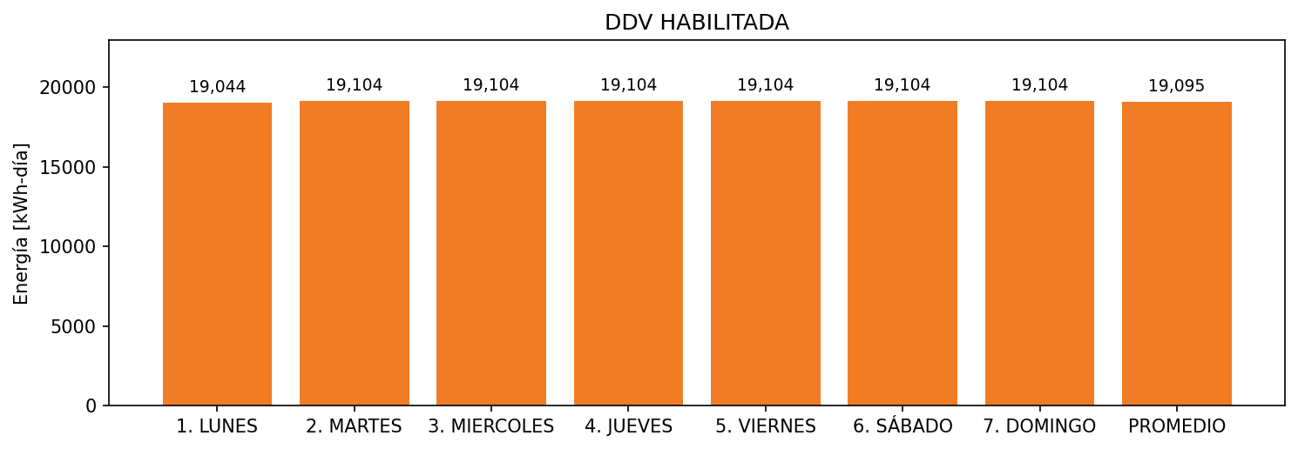

|  |  |  |  |  |  |  |  |  |  |
| --- | --- | --- | --- | --- | --- | --- | --- | --- | --- |
| **FRONTERA** | **COD SIC** | **FRT DDV** | **TIPO DDV** | **PROMEDIO** | **PRÓXIMA ACTUALIZACIÓN** | **MARGEN DE ERROR** | **ÚLTIMA PRUEBA DDV** | **DÍAS PARTICIPACIÓN** | **FECHA REFERENCIA PRÓXIMA PRUEBA DDV** |
| CARTAGENA HILTON | Frt10361 | Frt32733 | LBC | 19,095 | 2021-12-09 | 3,77 | 2021-09-01 | 37.0 | 2022-02-05 |